**CMPE:273 LAB-2 SPLITWISE**

**INTRODUCTION:**

* The purpose of this lab is to build a Splitwise clone.
* Splitwise is a free application used to track and share expenses between friends.
* The application has a single user persona.
* Every User is provided with a Dashboard to monitor the expenses.
* User can create a group

Youtube Link:​<https://www.youtube.com/watch?v=1ybxveN3Qr8>

**SYSTEM DESIGN:**

* **Database:**
* **Mongo database is used:**
* **Mongoose is used for storage.**
* **User**

UserId:EmailId of User-Primary Key-

UserName:Name of the user.can be changes

Profile:Link to the AWS S3 store where profile picture is uploaded

Currency:User Default currency

TimeZone:Time zone user operates.

* **Group**

GroupId:GroupId unique;y assigned to each group on group creation.

GroupName:Name of the Group.

CreatorEmail:Email Id of the creator.

Url:Link to the AWS S3 store where profile picture is uploaded.

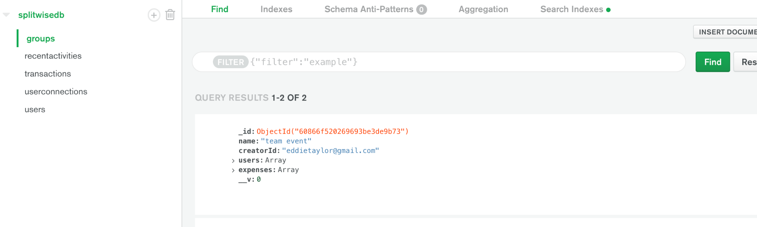

* **UserGroup(Connecting User and Group Table)**

GroupUserId:Unique systematically generated for each group-user pair.

UserId:User’s EmailId

GroupId:Groupid

GroupName:GroupName

Flag: Default values 0. Set when the user accepts an invitation.

* **User-User Group**
* UserId1 owes UserId2.
* For every group unique set of User1-User2 values.

UUID

UserId1

UserId2

GroupId

Owes

* **User-Group-Transaction**

UUID

EmailId

Description

Amount

GroupId

* **Recent-activity**

activityId

OperationType

GroupId

GroupName

* **ORM(Object Relational Model Mongoose)**

1. ORM converts a mongo into objects
2. Mongoose is a promise based node based ORM.

* **Backend Design:**
* 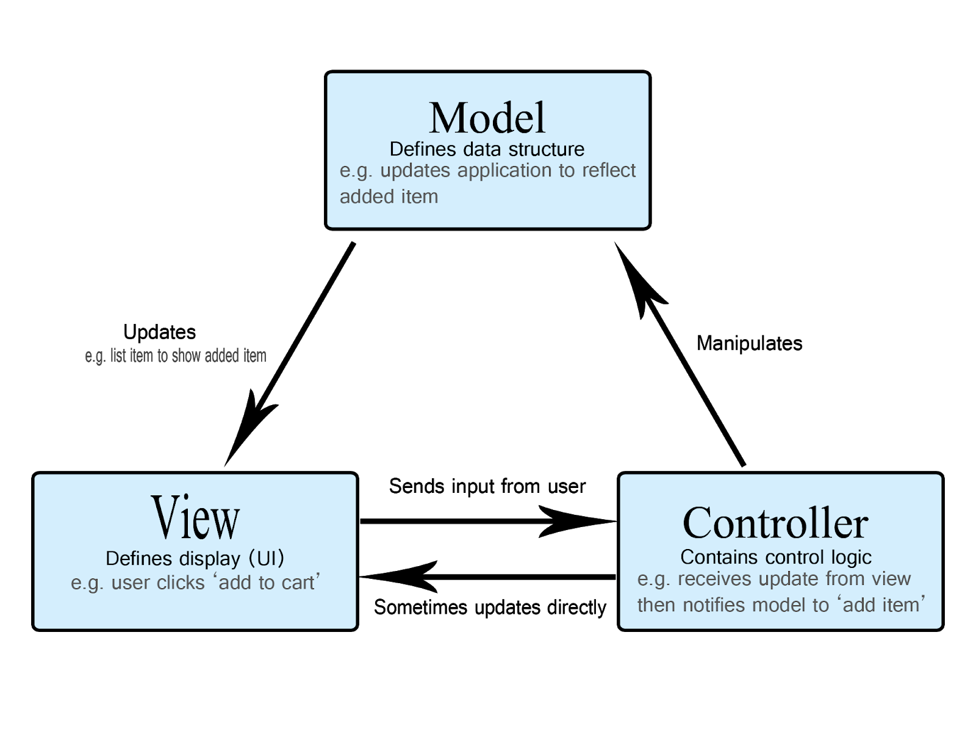A popular application architecture pattern MVC(Model Controller View) is used in this project.
* Model accesses the database and serves the data in object format.

KAFKA

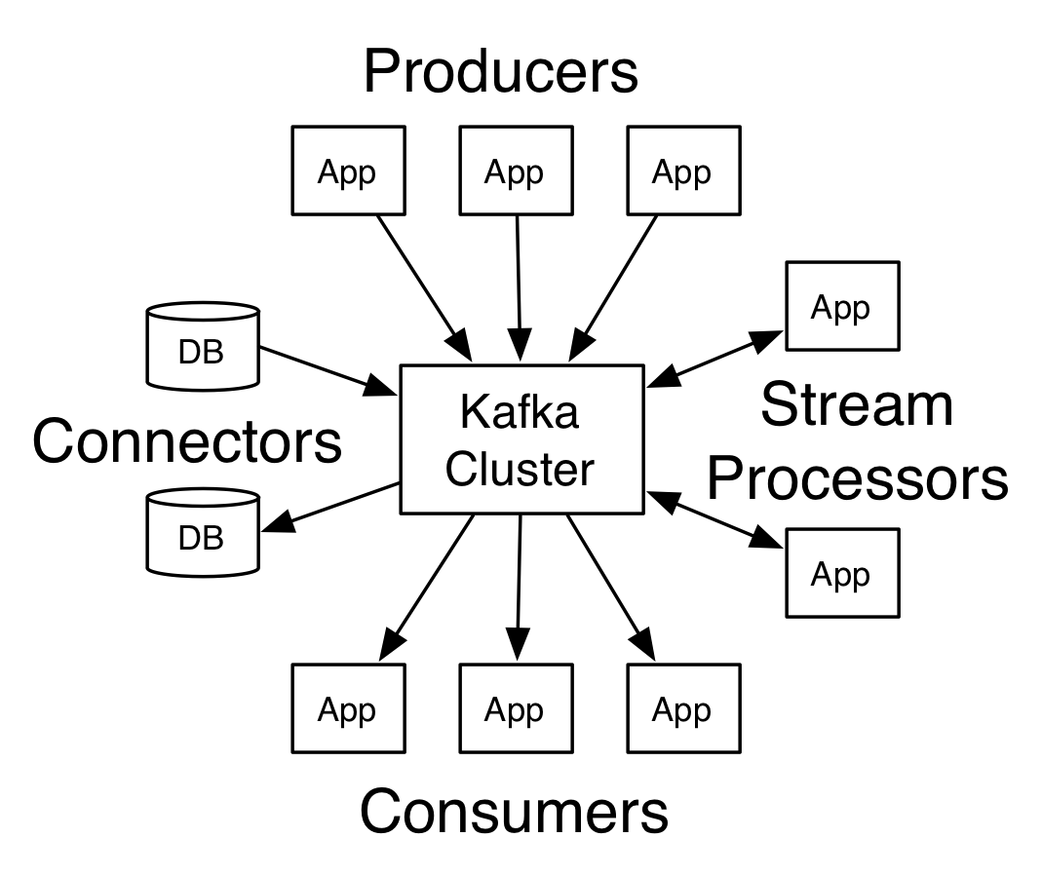

* **Frontend UI:**

**Landing page:**

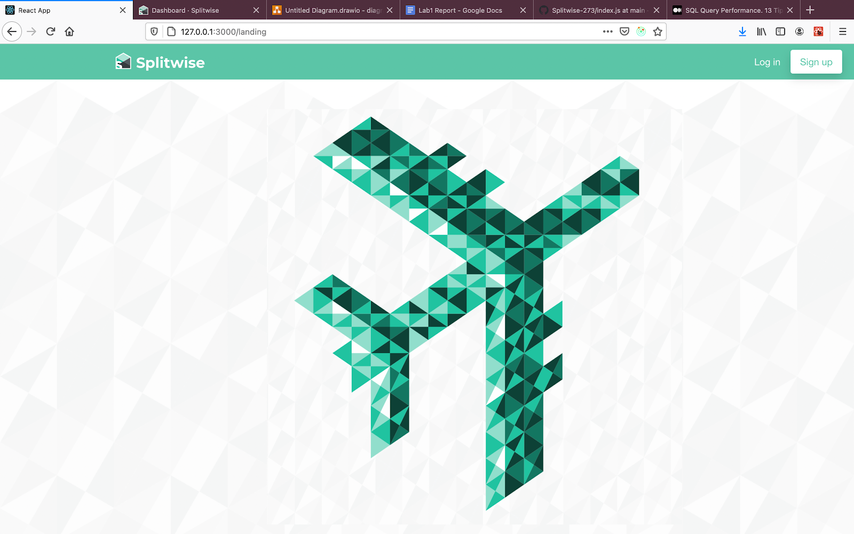

**Login:**

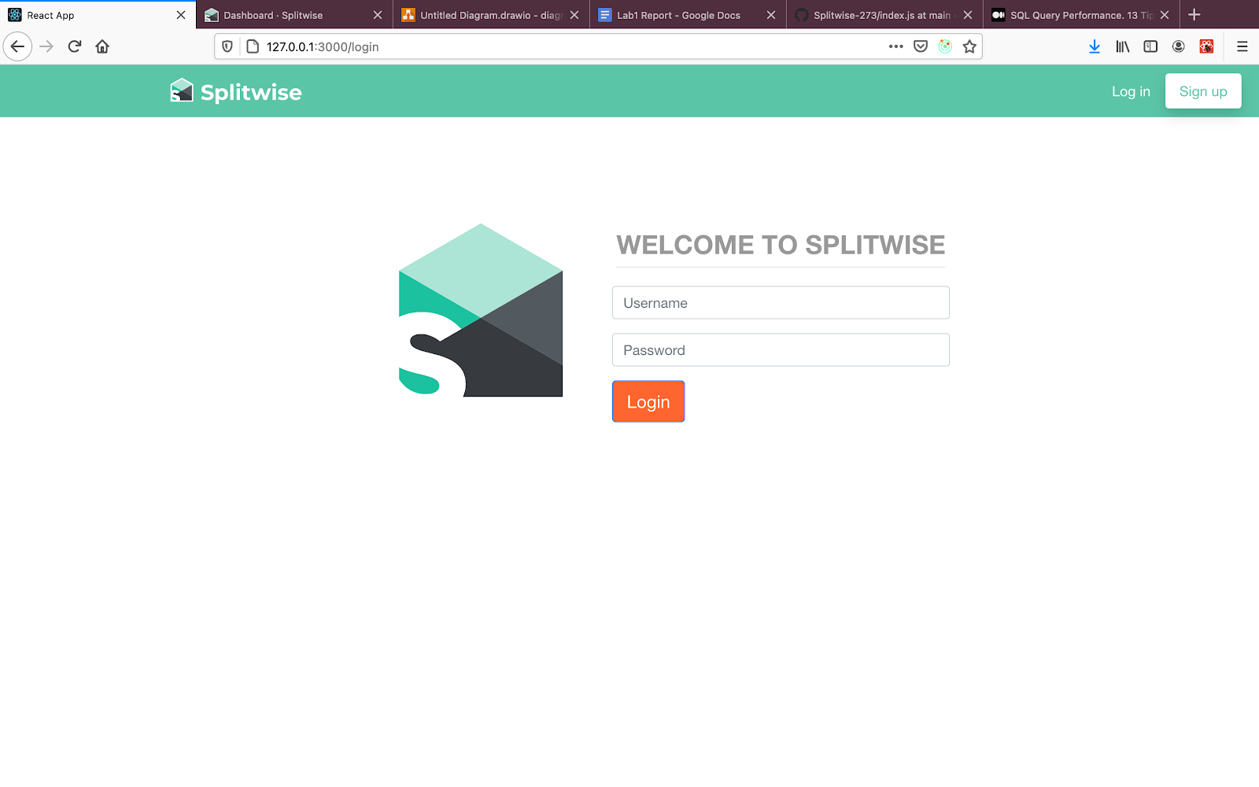

**Register:**

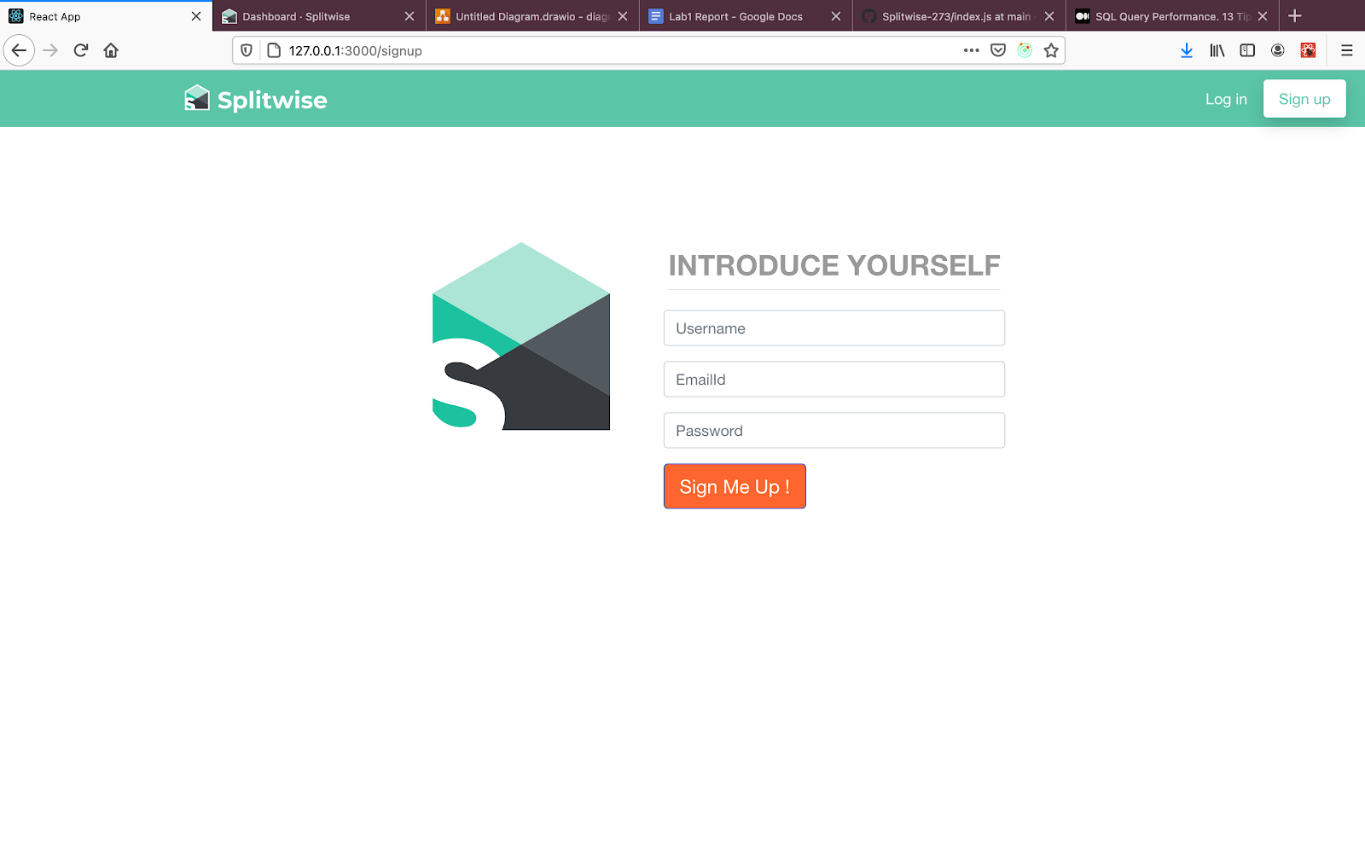

* **Recent Activity:**

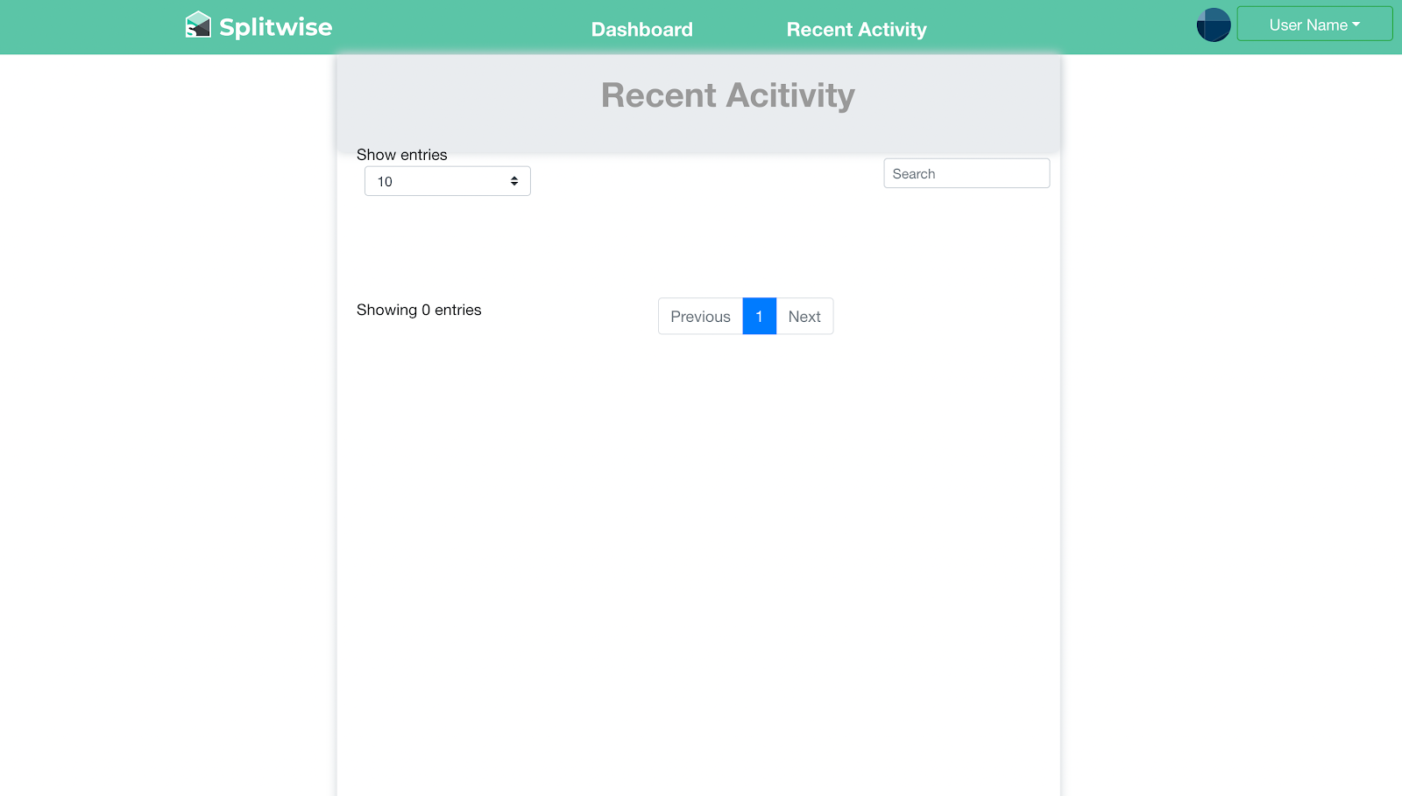

**Settle up:**

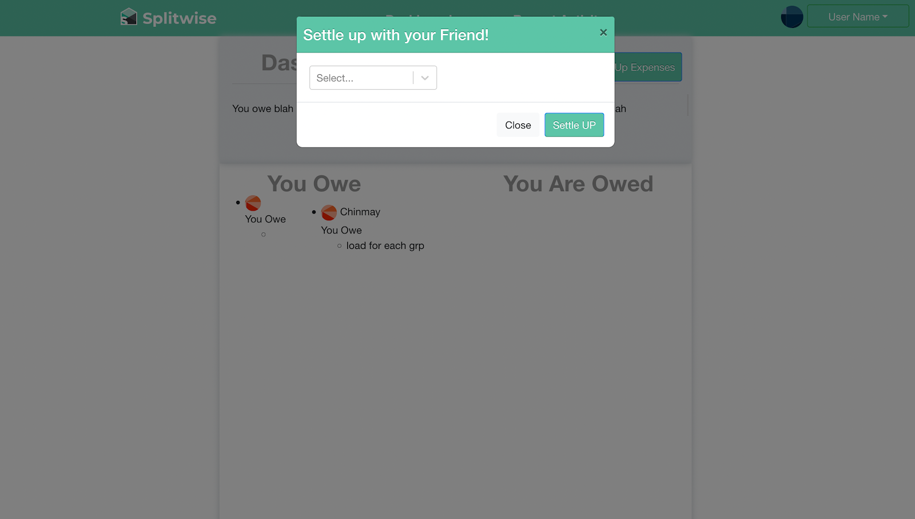

**Profile page:**

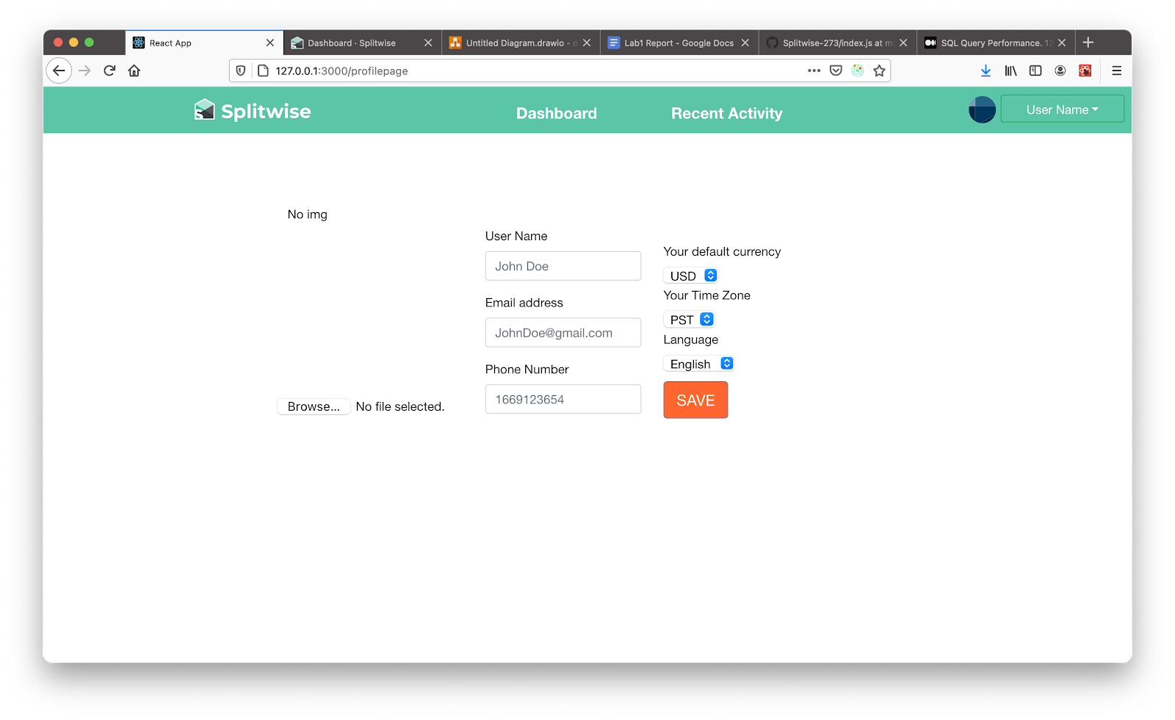

**Dashboard:**

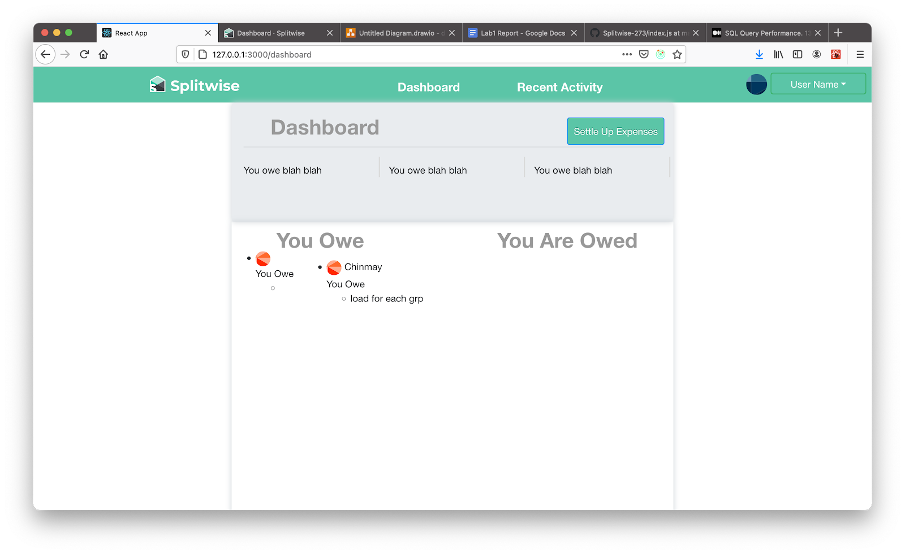

**Create group:**

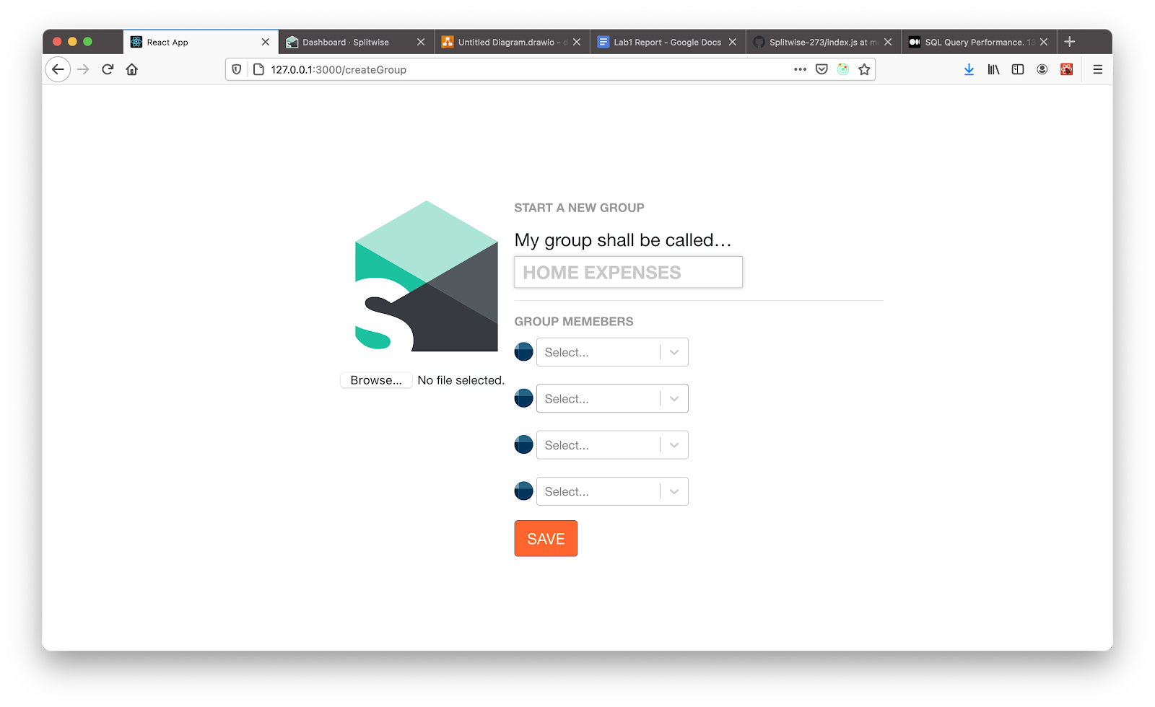

**My groups:**

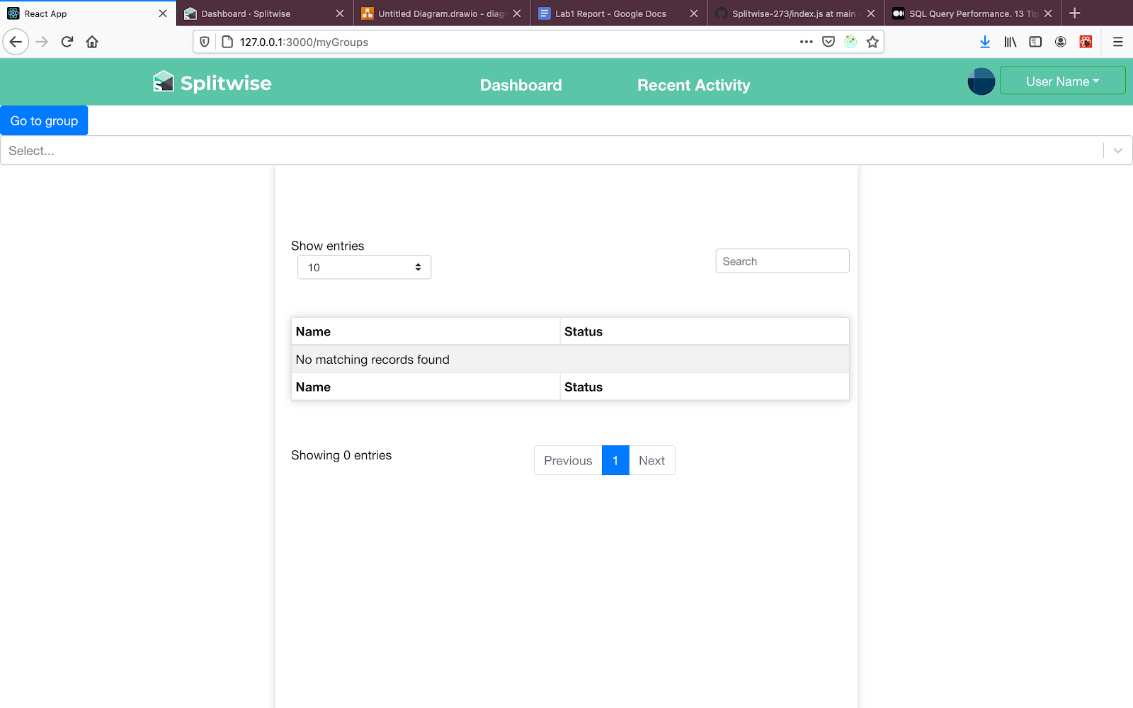

**Group Page:**

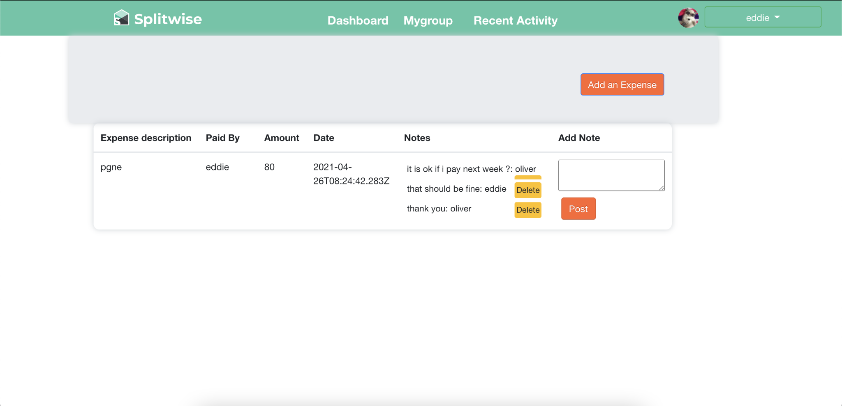

**Commit history:**

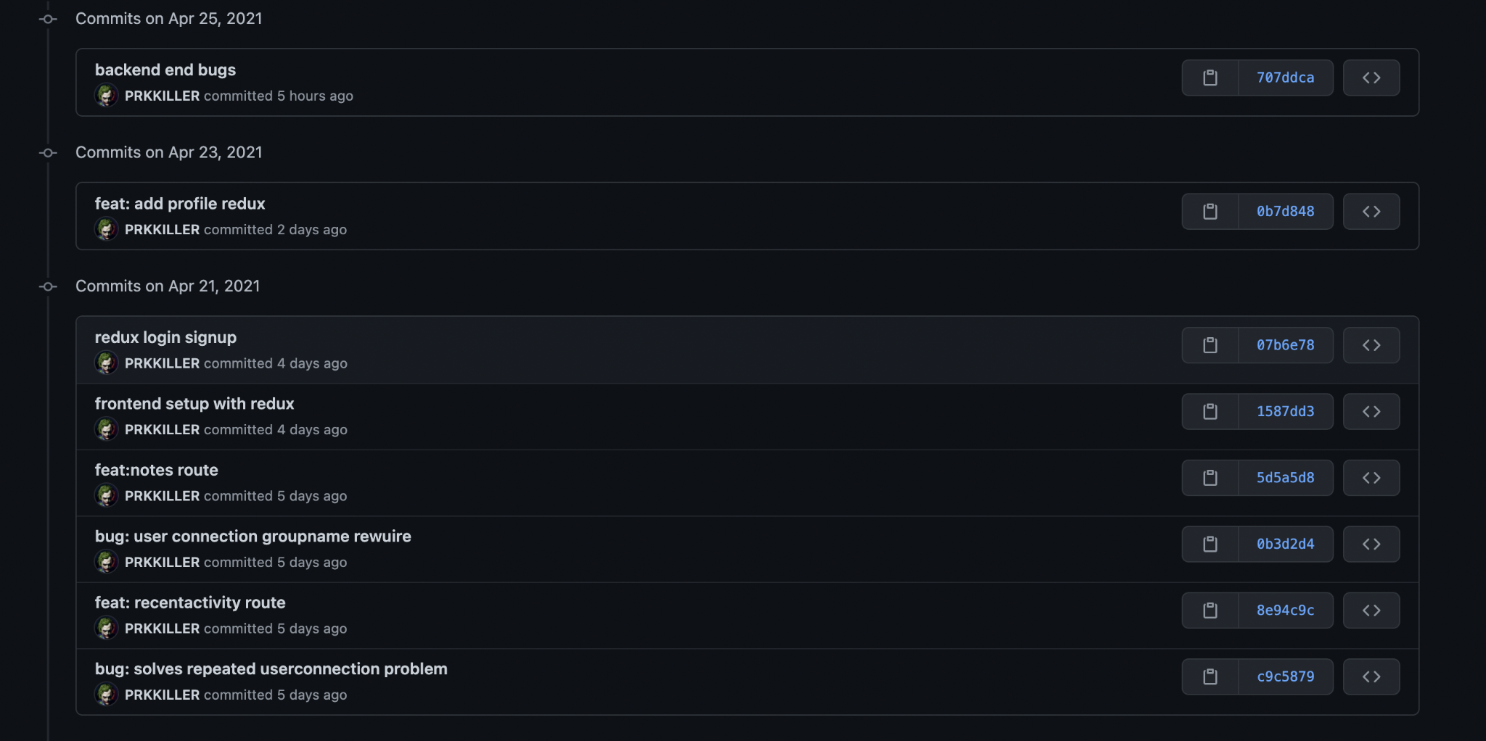

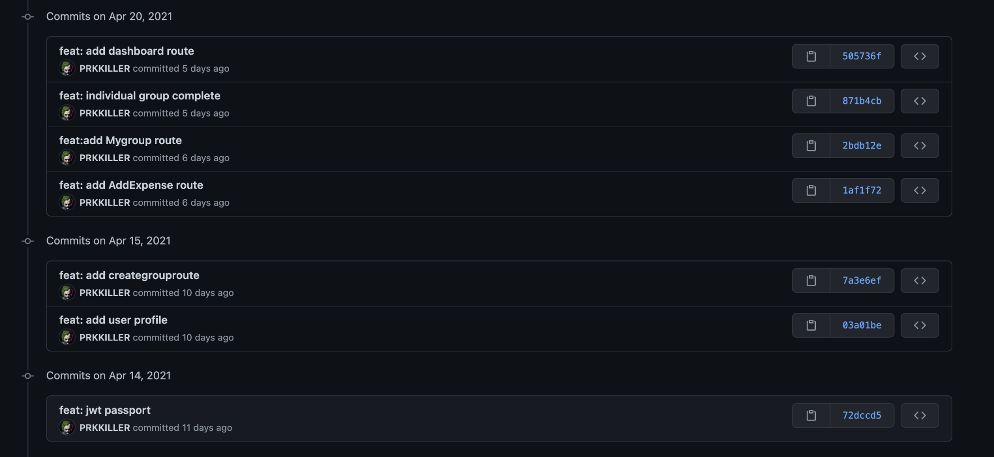

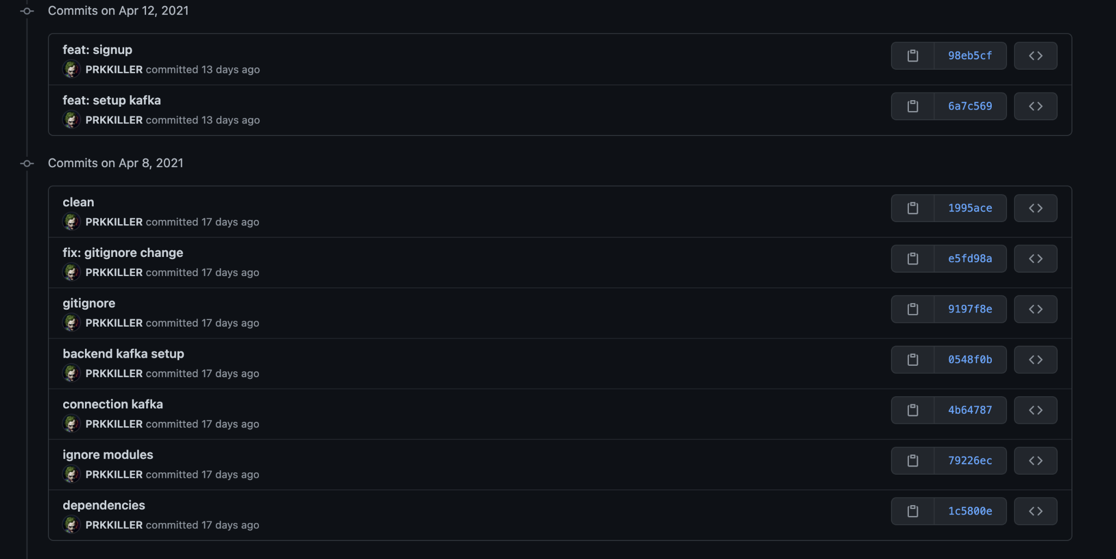

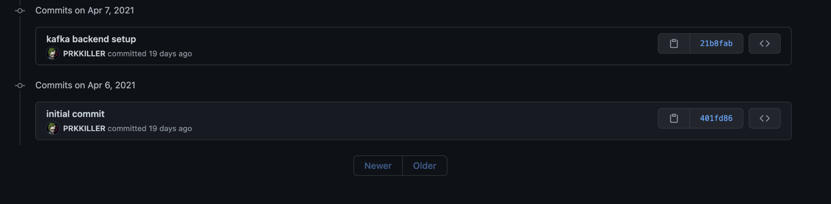

**Mocha testing:**

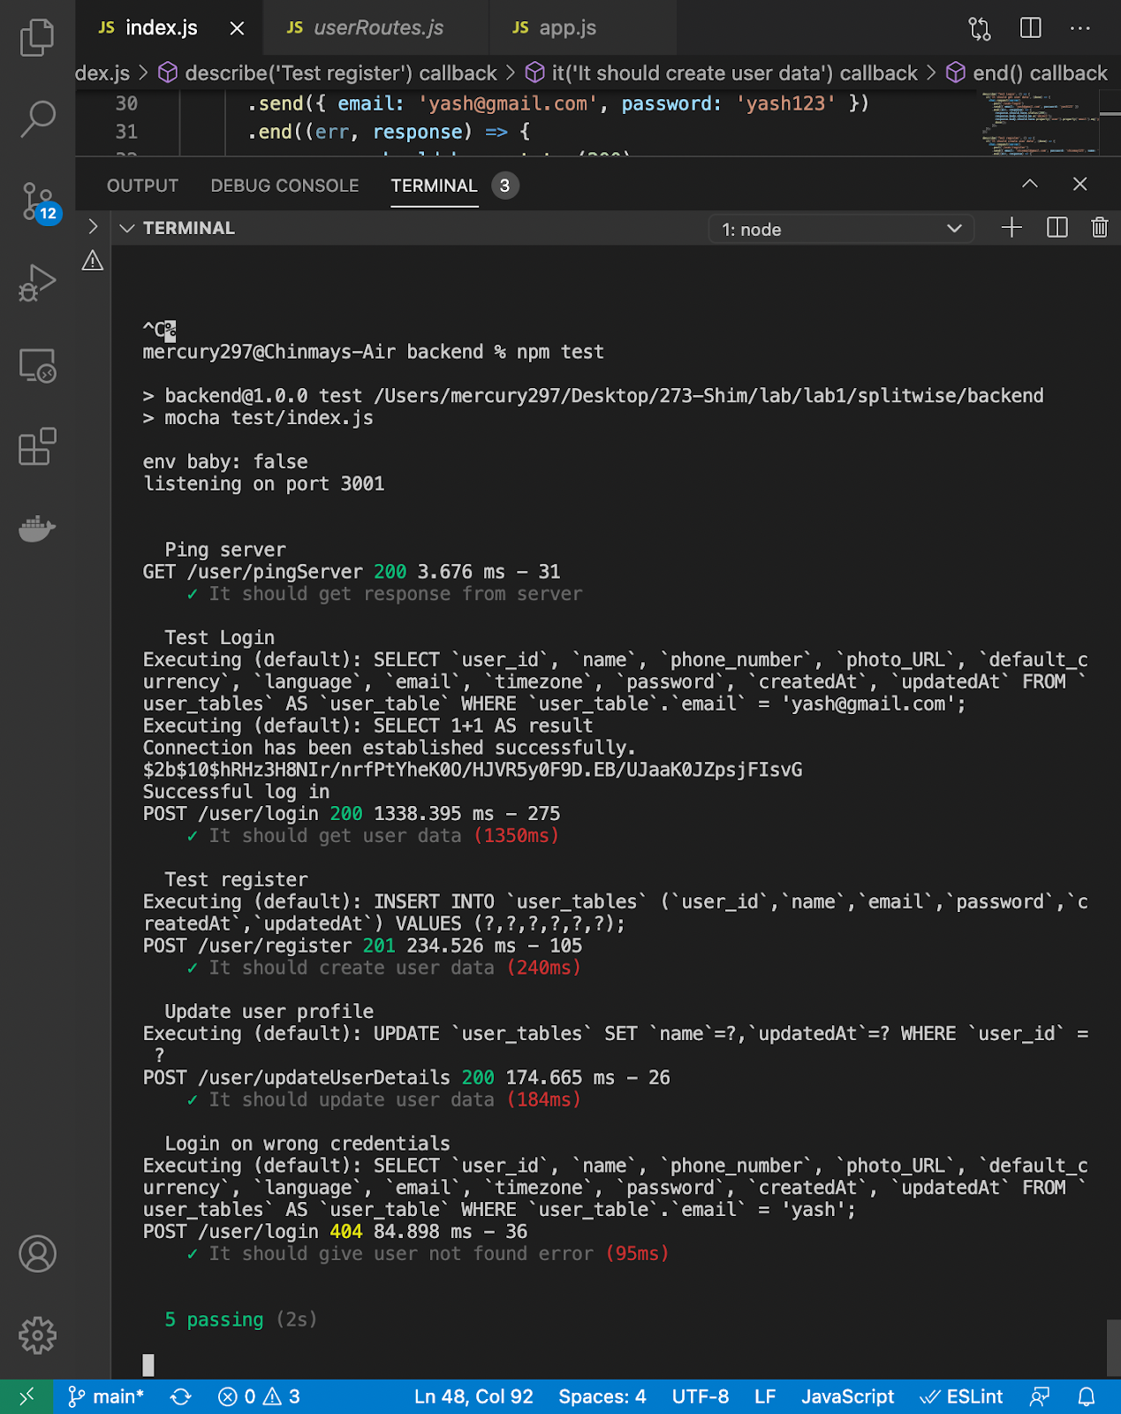

* **Jmeter Testing**

100 Users Without Pooling

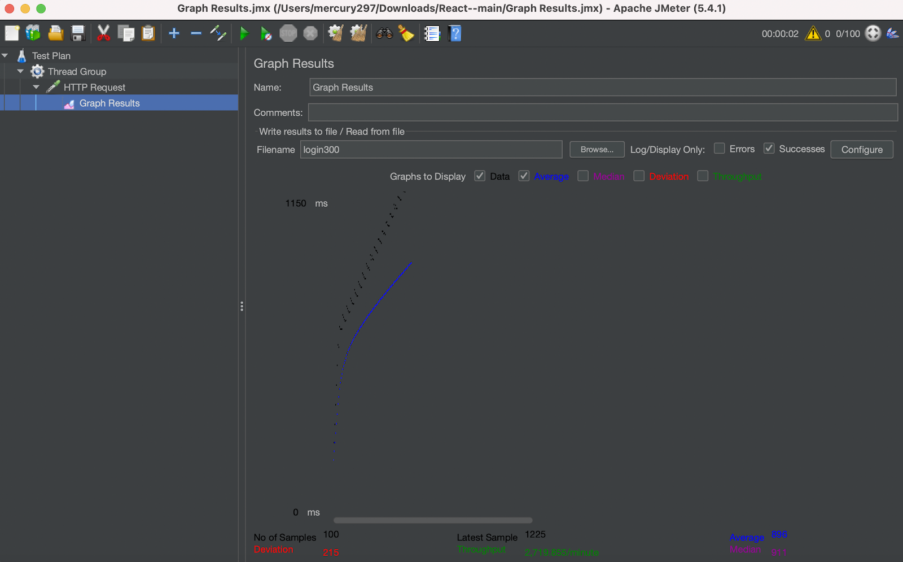

200 Users without pooling

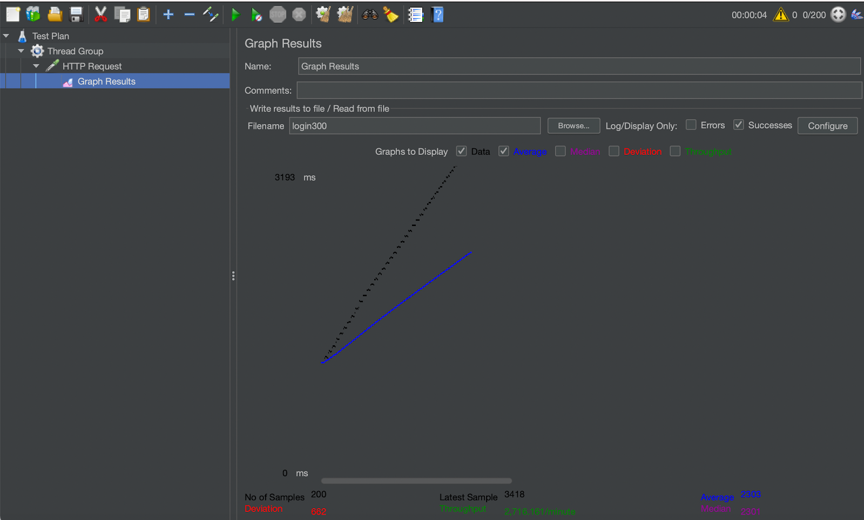

300 Users without pooling

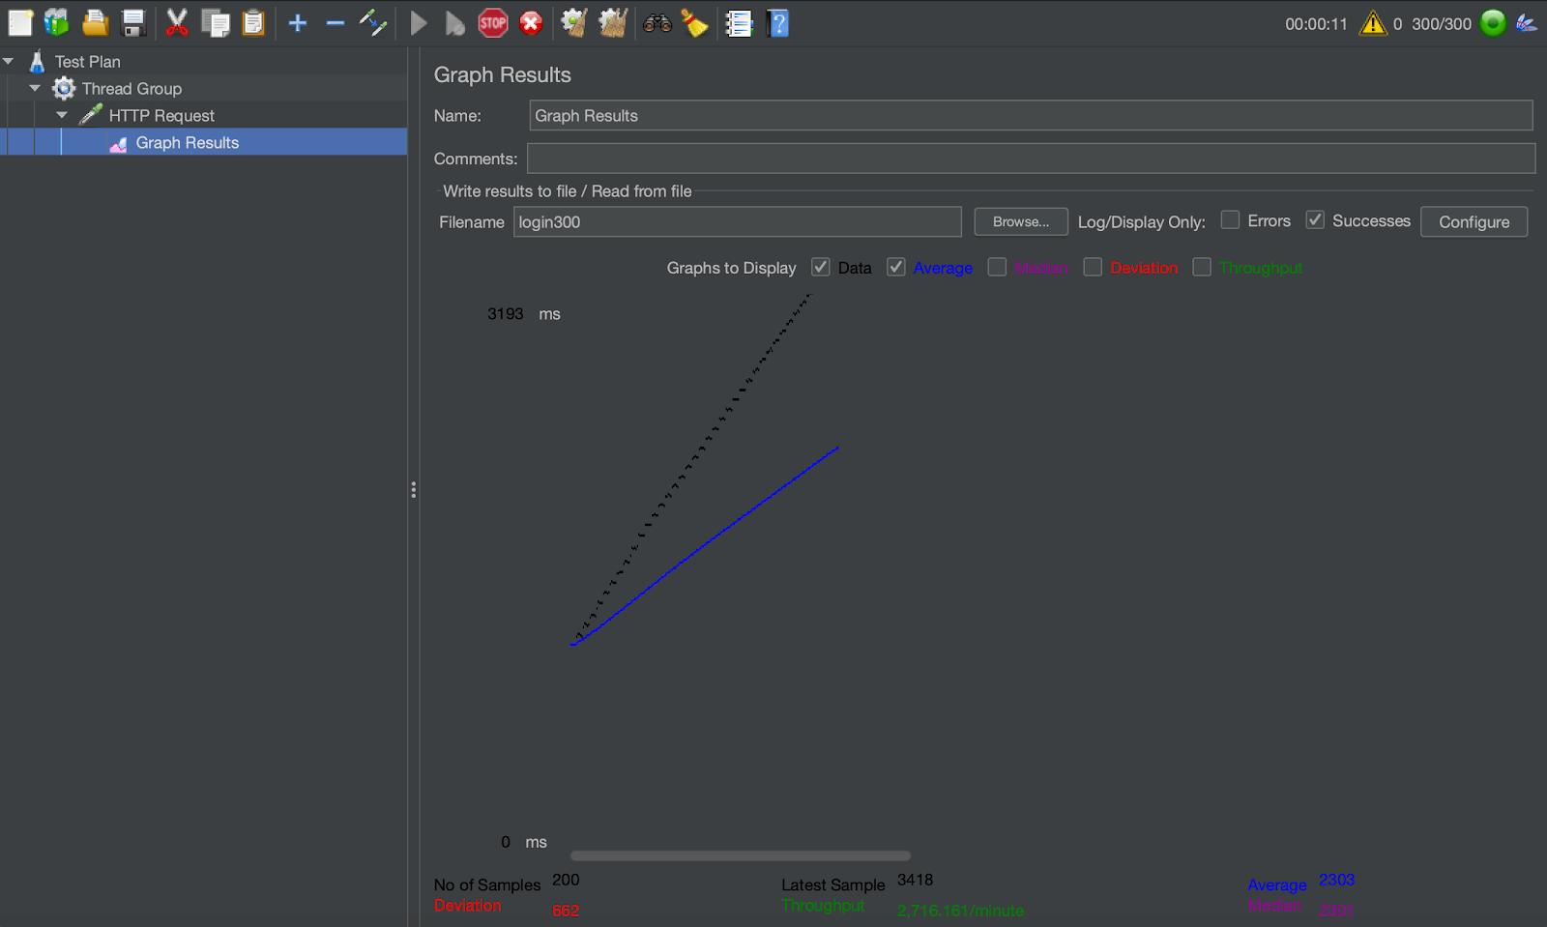

400 user without pooling

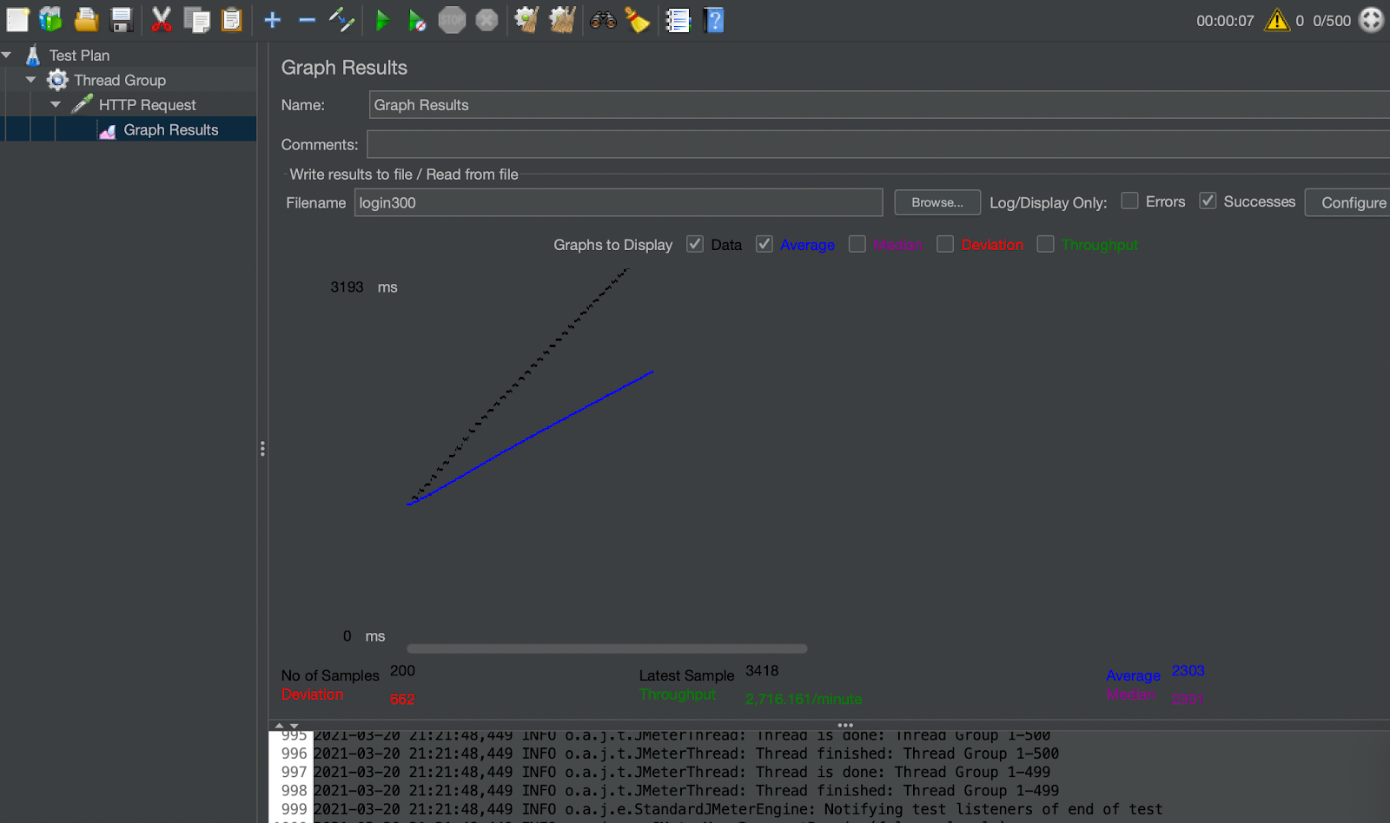

100 Users with pooling

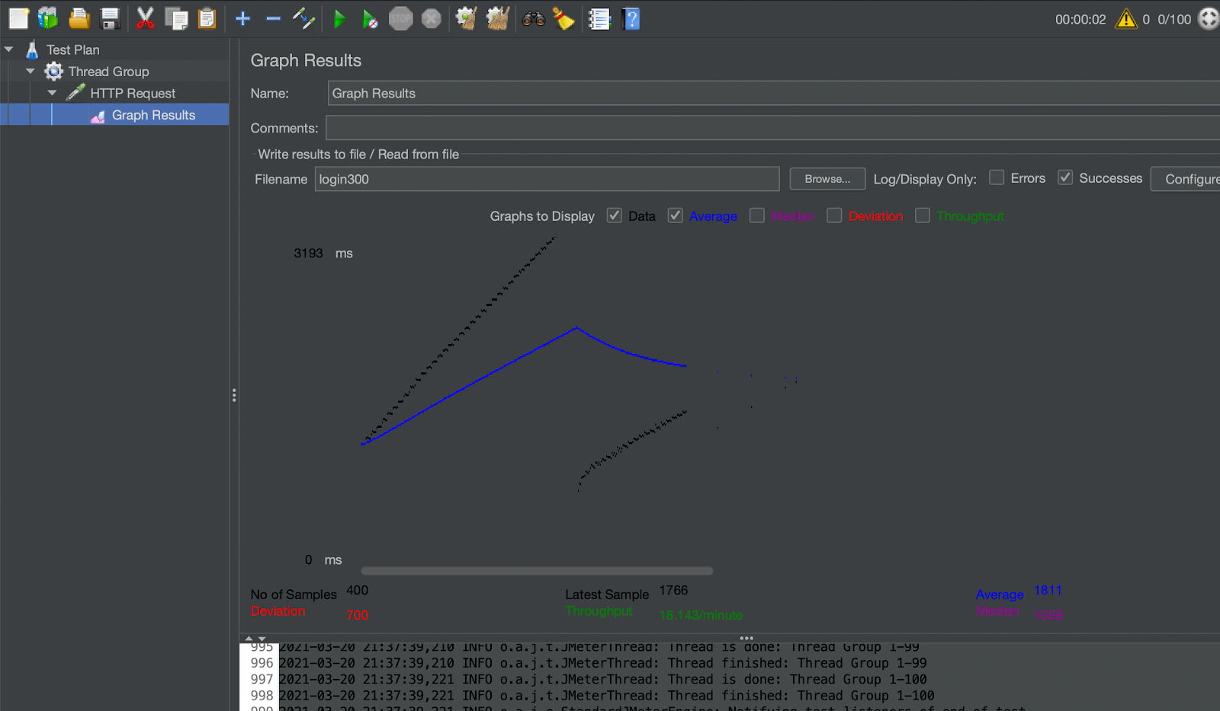

200 user with pooling

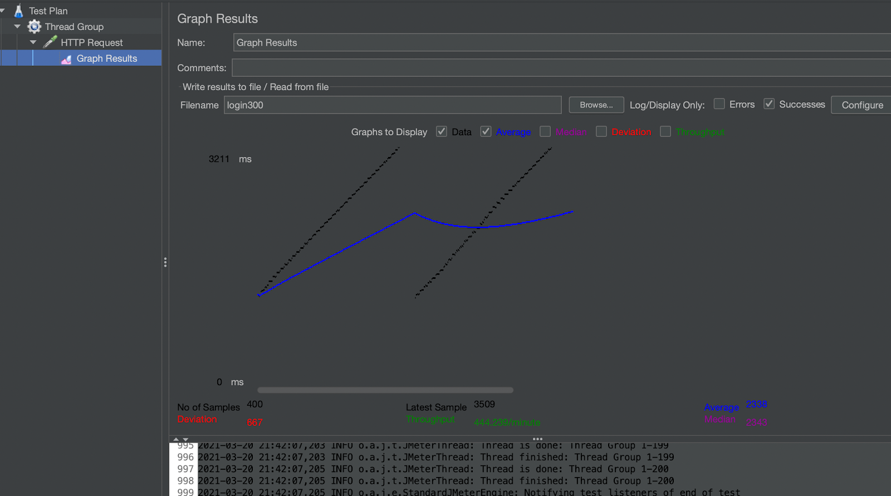

300 users with pooling

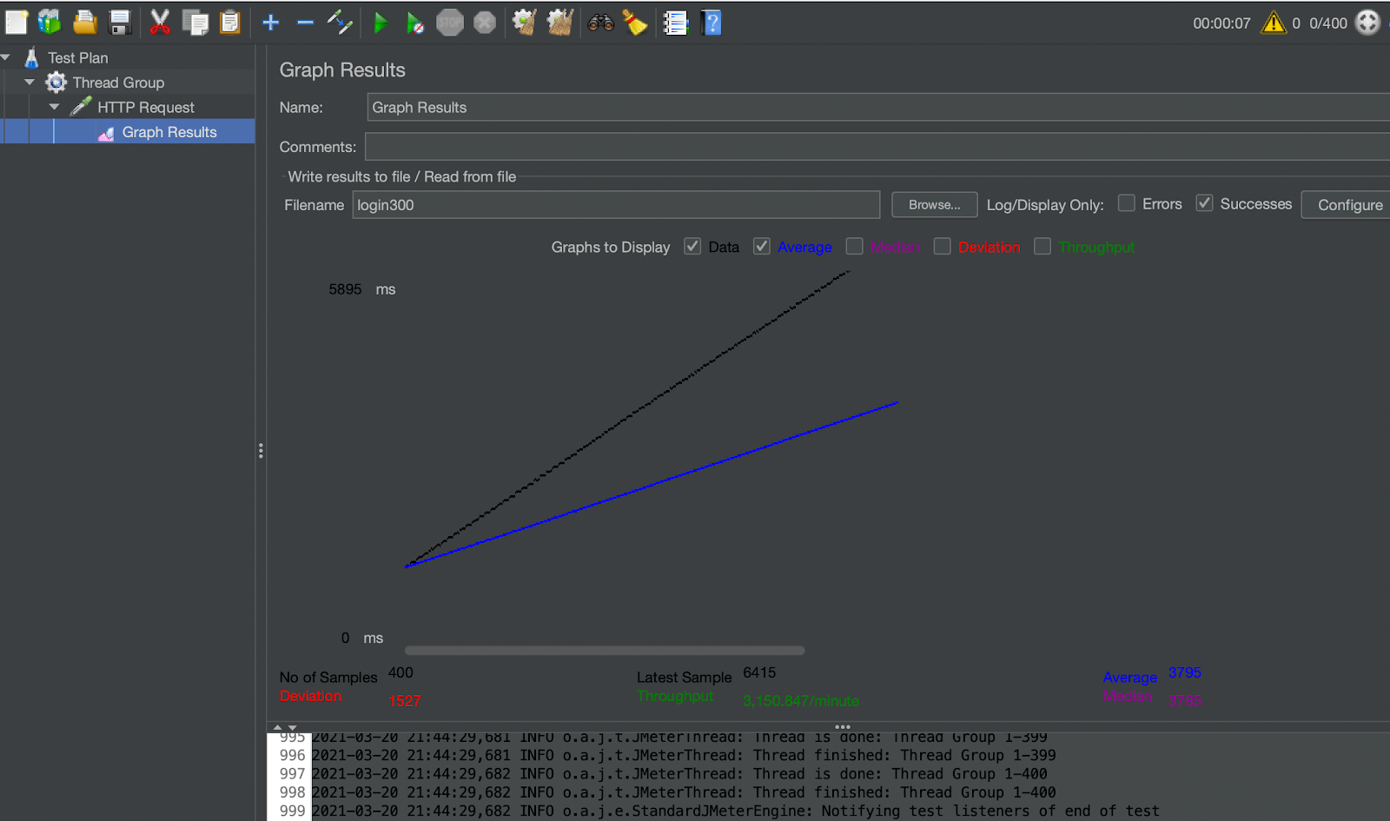

400 users with pooling

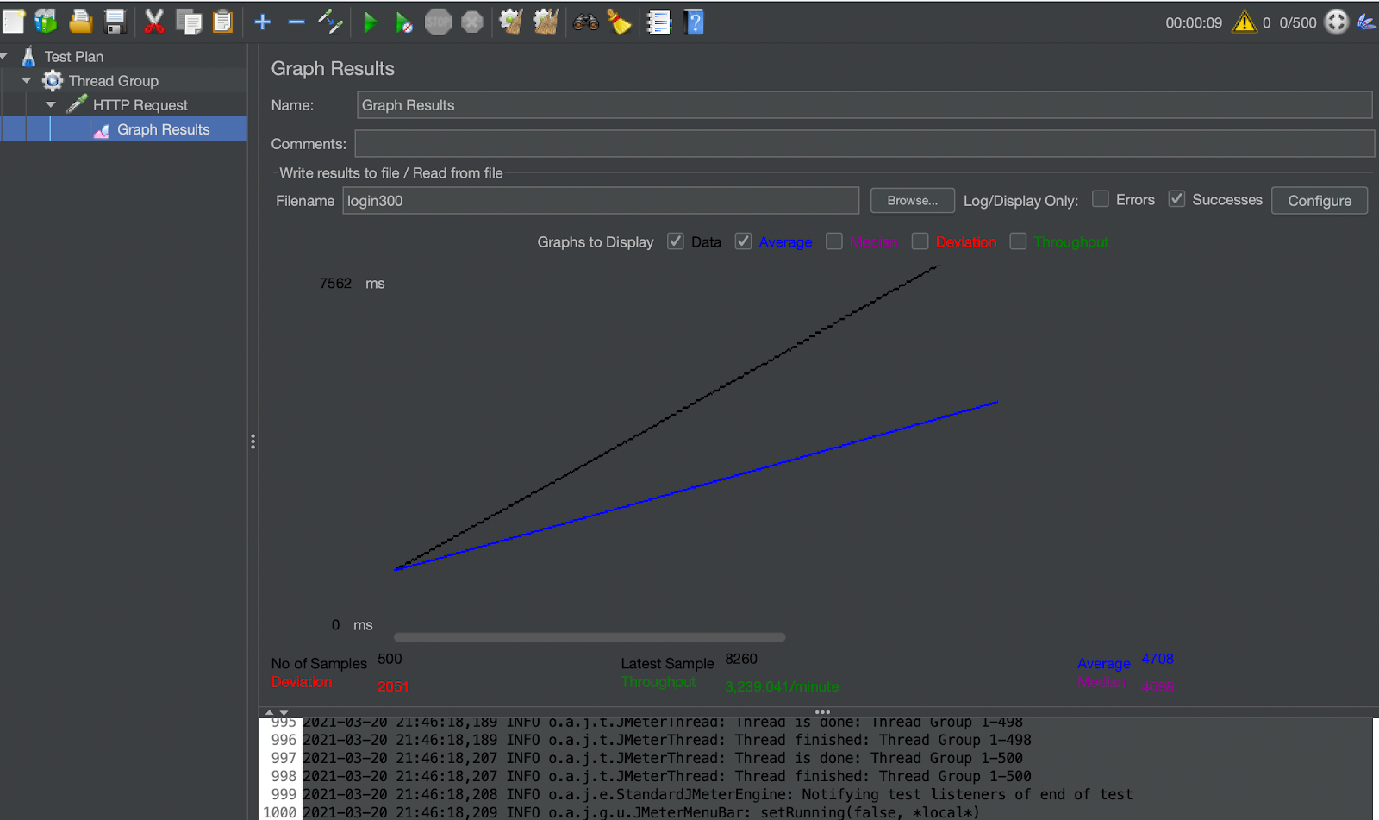

500 users with pooling



**Answers to the questions:**

1. For authentication in the first lab I used the local storage to persist user information that was necessary for all the routes. This time around I incorporated JWT tokens using passportJS and protected all the routes with these tokens. These tokens had user information encrypted in them and they also have a limited expiry period. This means that every resource is protected using these stateless tokens and also they will always only have the fresh data. Hence, it can deduced that using JWT tokens is the more scalable and secure technique of authentication
2. The kafka framework is stream-processing bus software which means it is a high end message queue. Given the extent of the splitwise clone there were not too many concurrent requests and the number of services was limited. But using kafka in this project ensured that the services in use are all parallelized. For example, when the dashboard data is requested by two users both the requests are sent to Kafka as two atomic messages and these messages get data from the Database and send response as another set of atomic messages. This divides these two requests into four parallel units as opposed to two. Now when the replication factor and partitions are increased the parallelism also increases. In this way the application is exponentially more scaled than it was initially. Although the performance difference will really show when there will be multiple concurrent users requesting the API service
3. Given my implementation, the user and the group tables are such that they’re almost mutually exclusive and don’t have cascading effects on one another. But the transactions table is heavily related to the both of them which increases the groupby functions on these tables. These tables if stored in the MySQL database will preserve their relational attributes thus making groups and joins easier whereas the user and group tables will be stored in the MongoDB database making it easier to write and read from as a lot of information can be embedded in them making reading easy. Thus the dashboard or group summaries will be fetched very fast.